Fish some real Irish countryside with Celtic Angling
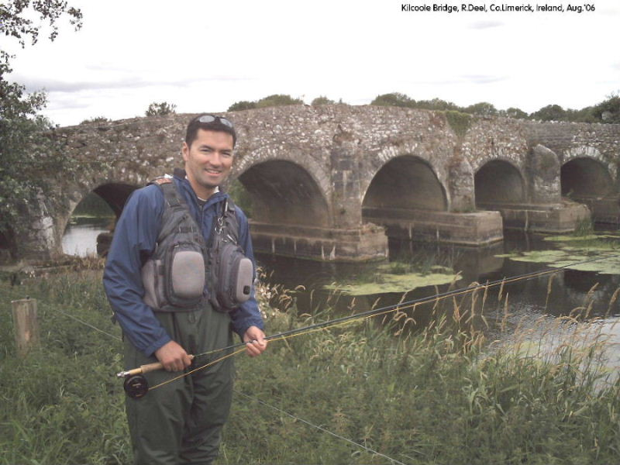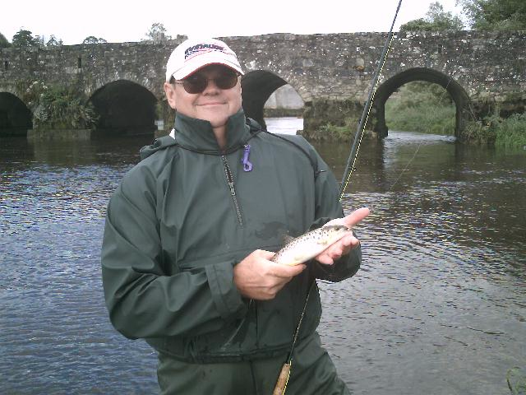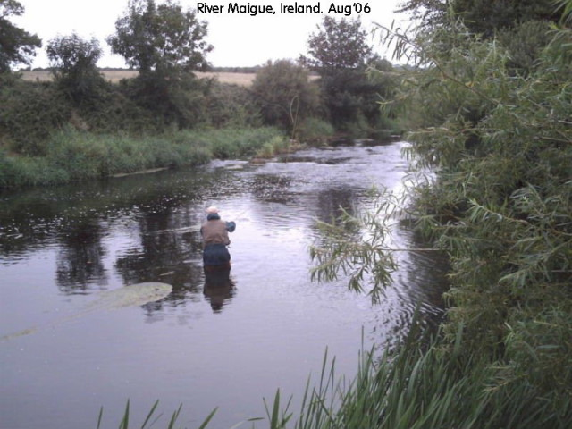

With Celtic Angling – Full day for 2 anglers - Includes 4-wheel drive collection from Adare Manor, licences/ permits for R. Maigue or R. Deel, personal guiding and tuition with qualified ‘ Marine and Countryside Guide’ Paddy Dunworth, packed lunches, complimentary beer/soda, fishing outfits, flies waders, polaroids, wetgear, photos/videos of day etc etc. Total cost for 2 anglers full day = 250euro Total

Same package with Adare Manor Fishing charges (As taken from website www.adaremanor.com – Activities > Fishing) Total cost for 2 anglers at Adare Manor Rates = 890euro Total
Breakdown as follows:
(Fishing within Adare Manor Hotel compound only)
Adults €65.00 per person per hour, €45.00 per hour thereafter
Children under 12 €35.00 per hour, €30.00 per hour thereafter
Tackle, Bait & License €45.00 per person per day so
Take a typical case of 2 anglers for full day (7hrs)

Guiding cost @ 2 x 130eu + 6 x 90eu = 800euro
Tackle + bait + licence = 90euro

l

Plus, you get to see and fish real Irish countryside with Celtic Angling!



