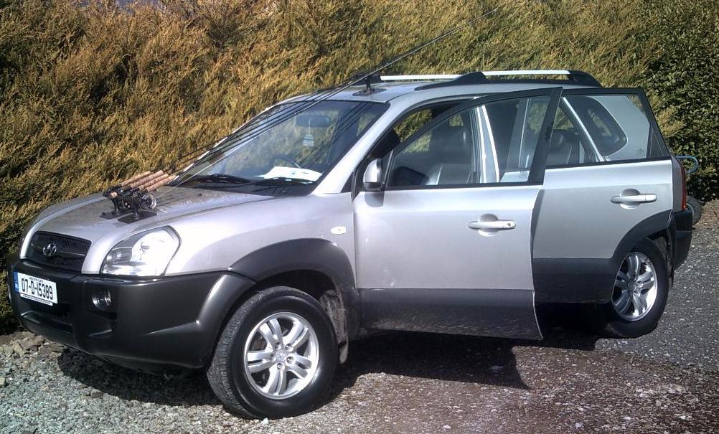Celtic Angling transport

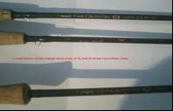Over 40 models of Rods by Temple Fork and Bruce & Walker

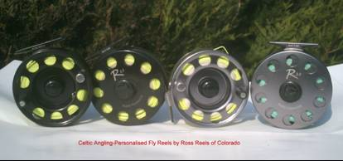Personalised flyreels by Ross Reels

